1-Consider “ m-k Compressor” what is the relation between m and k?

a)k=m-3 b)k=3m c)k=m+2 d)k=2m e)?

2-Which one is (are) universal gate (s)?

a) Nor b)Mux c)Xor d)Minority gate e)?

3 What is the truth table of HA- -?

a) 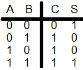 b) 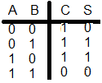 c) 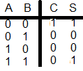d) 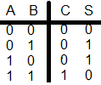e)?

4- This Truth table belongs to which gates?

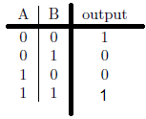 a-Nor b-Nand c-Xor d-And e?

5- Which ones have the same outputs?

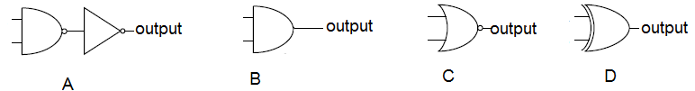 e)?

1-A and B 2-A and C 3-B and D 4-B and C 5?

6-Which ones have the same outputs?

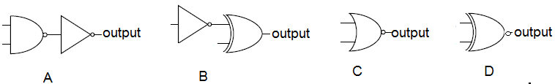

1-A and B 2-A and C 3-B and D 4 4-B and C 5?

7- Which one(s) is (are) example(s) of Approximate Computation applications?

a)Spy Fly b)Sensor Network c)Image Processing d)all e)?

8- This truth table belongs to which approximate gate?

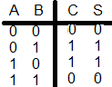

a)HA b)HA- c)HA-- d)HA+ e)?

9 - What is the function of this circuit?

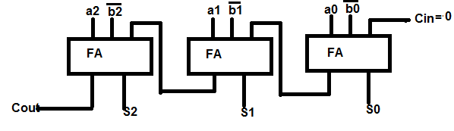a) A+B b) A-B c) A+B+1 d) A-B-1 e)?

10-Design a question and answer it.